How to implement access control

1. Create Group and select permissions for different group

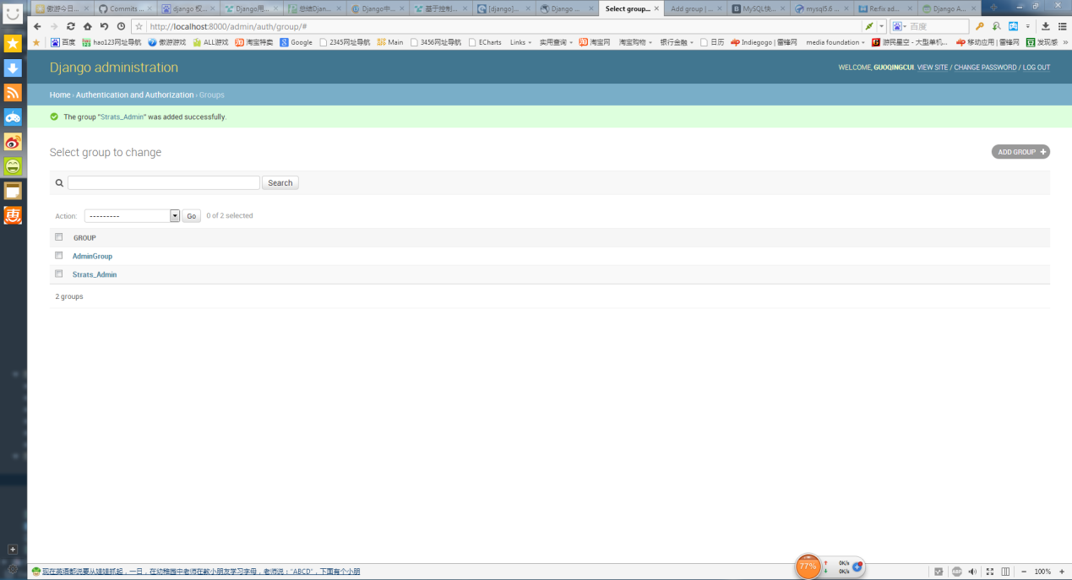

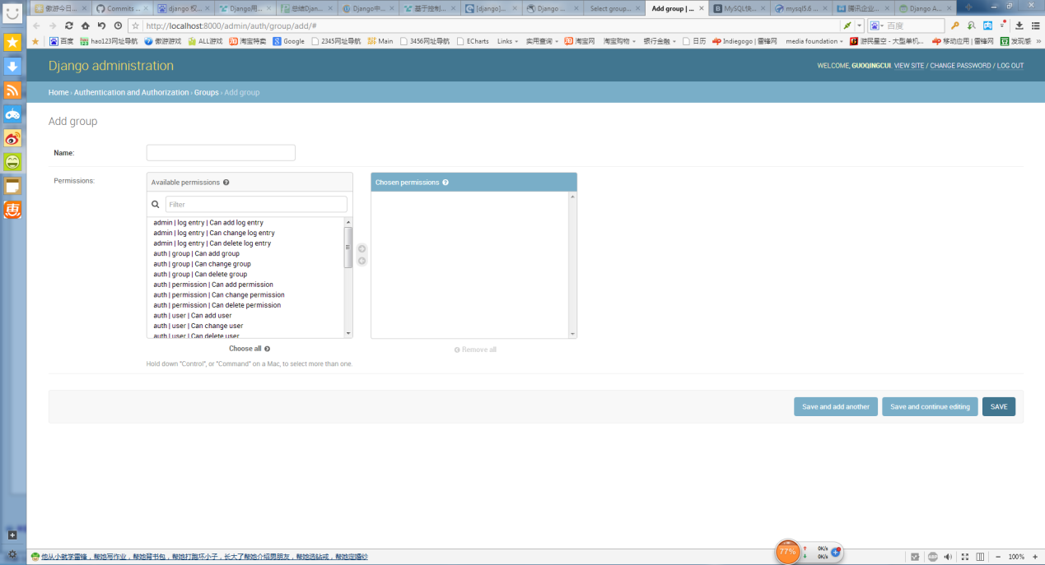

1. Go to users page and add group for user, user will have the same permission as group.

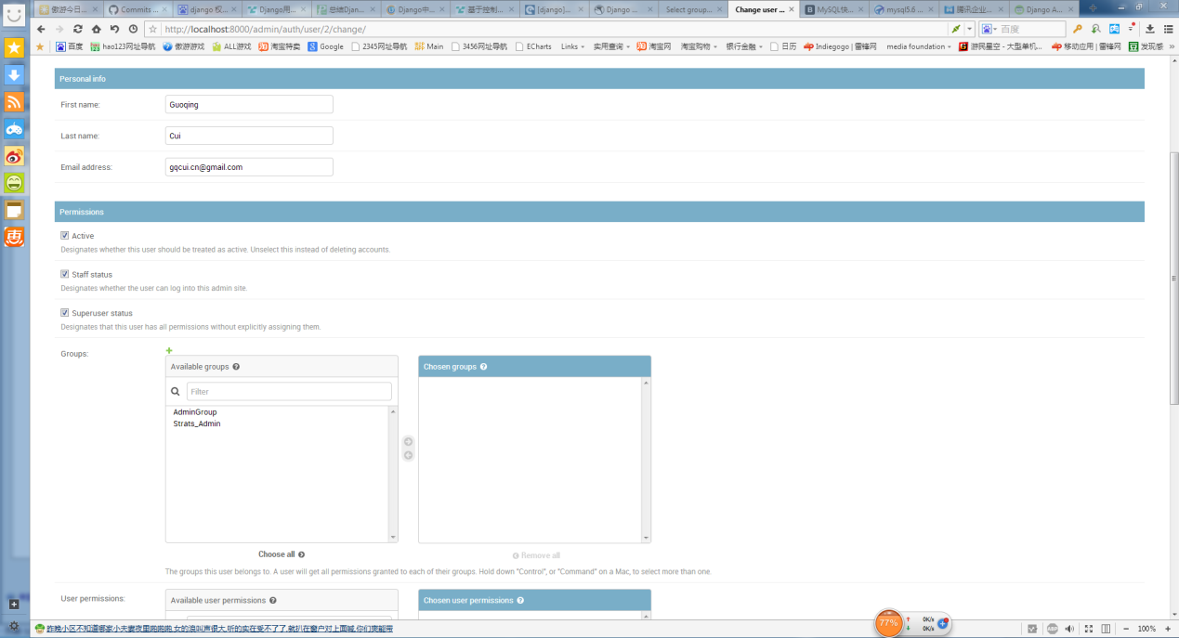

1. You can also setup permission for each user not based on group.

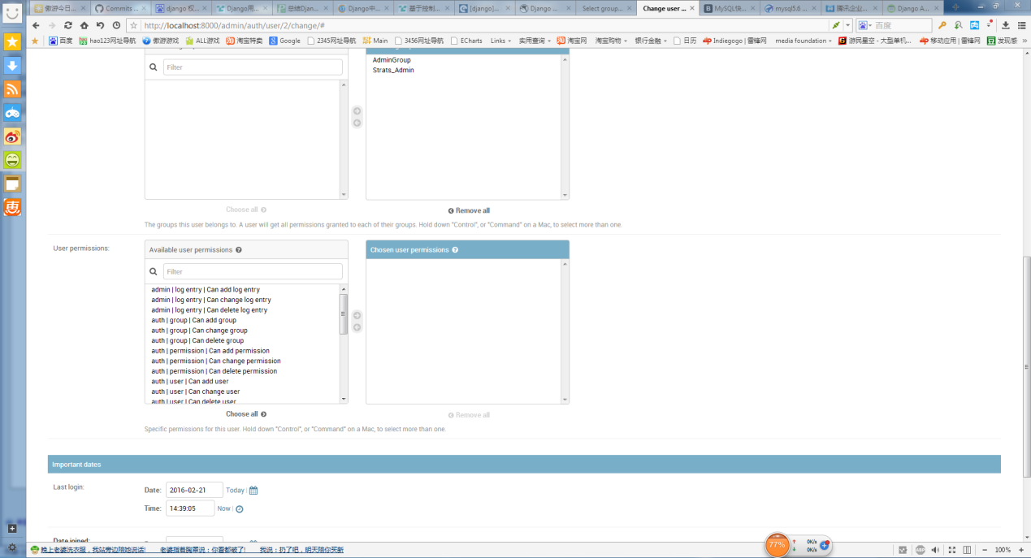

1. 3 methods to make change in code.
2. Use decorator before view. This is not work for me somehow.

**from** django.contrib.auth.decorators **import** login_required,permission_required

@login_required  
@permission_required('prototype.view_test_result')  
**def bigdata_trend_test_result**(request):  
 **if not** request.user.is_authenticated():  
 **return** HttpResponseRedirect('/login/?next=%s' % request.path)

1. Check permission in view.

**if not** request.user.has_perm('prototype.view_test_result'):  
 **return** HttpResponse("您没有运行回测的权限，请联系管理员。")

1. Check permission in template. perms is the global variable.

{% block content %}  
 {% if perms.prototype.view_test_result %}